
Lab 02
Topic | Entity Relationship Diagram
Objective | - Understand ERD concepts.  - Identify entities & attributes.  - Define primary & foreign keys.  - Understand relationship types.  - Convert ERD into tables.
Learning Outcomes of This Lab:
After completing this lab, students will:
- Understand ERD concepts.
- Identify entities & attributes.
- Understand relationship types.
- Convert ERD into tables.

Entity Relationship Diagram
What is ERD?
An Entity Relationship Diagram (ERD) is a graphical representation of a database structure.
It shows:
- Entities (tables)
- Attributes (columns)
- Relationships between entities
ERD is used during the database design phase before creating actual tables.

Why we use ERD?
ERD helps to:
- Understand system requirements
- Visualize database structure
- Identify relationships
- Reduce redundancy
- Plan normalization
- Avoid design mistakes
It acts as a blueprint of database.

Basic Components of ERD
There are three main components:
- Entity
- Attribute
- Relationship

Entity
An Entity is a real-world object about which data is stored. It represents a table in database.

Examples
- Student
- Course
- Teacher
- Department
- Book

Attributes
Attributes are properties or characteristics of an entity. They represent columns in a table.

Example (Student Entity)
Student has:
- RegID
- Name
- CGPA
- Contact

Types of Attributes

1. Simple Attribute
Cannot be divided further.
Example:
- CGPA
- Age

2. Composite Attribute
Can be divided into smaller parts.

Example:
- Name → FirstName, LastName
- Address → City, Street, ZipCode

3. Single-Valued Attribute
Has only one value per entity.
Example:
- DateOfBirth

4. Multi-Valued Attribute
Can have multiple values.
Example:
- PhoneNumber
- Skills

5. Derived Attribute
Calculated from another attribute.
Example:
- Age (calculated from DateOfBirth)

Relationship
A Relationship shows how two entities are connected.
Example:
- Student enrolls in Course
- Teacher teaches Course

Types of Relationships (Cardinality)
Cardinality defines how many instances of one entity relate to another.

1️ One-to-One (1:1)
One entity instance relates to one instance of another entity.
Example:
- One person has one CNIC.

2️ One-to-Many (1:M)
One entity relates to many instances of another.

Example:
- One Department has many Students.
- One Teacher teaches many Courses.

3️ Many-to-Many (M:N)
Many instances relate to many instances.
Example:
- Students enroll in many Courses.
- Courses have many Students.
⚠ Many-to-Many must be converted into associative entity when creating tables.

Example ERD – University System
Entities:
Student
- RegID (PK)
- Name
- CGPA
Course
- CourseID (PK)
- CourseName
- CreditHours
Relationship:
Student enrolls in Course
Cardinality:
Many-to-Many

Advantages of ERD
- Clear visualization.
- Better database planning.
- Reduces design errors.
- Improves communication.
- Helps in normalization.

Lab Tasks

Task 01
Consider a database system for Library Management System. Draw ERD Diagram on the given scenarios. The data requirements are summarized as follows:
Business Case: Library
A college library maintains records of books and students. Each student can borrow books from the library. Each book is written by one author. A student can borrow multiple books, and a book can be borrowed by many students (at different times).
Draw ERD to show entity, attributes and relations between these entities.
Tool: Use online ERD Plus tool.

Solution:

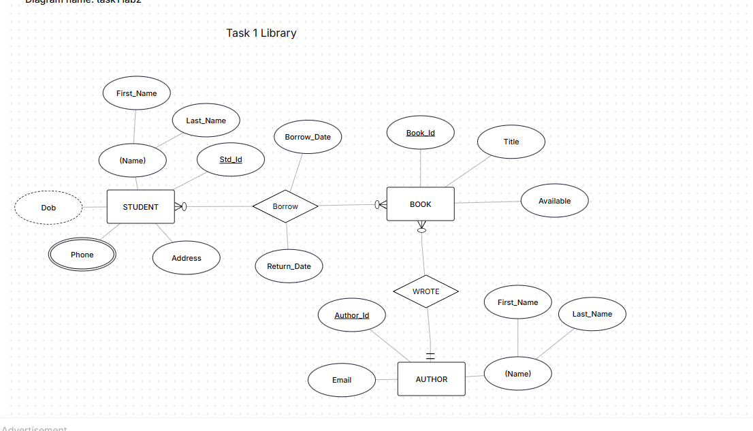

Task 02
Business Case: Small Hospital
A small hospital keeps records of patients and doctors. Patients visit doctors for treatment. Each doctor works in one department. A patient can visit many doctors, and a doctor can treat many patients.
Draw ERD to show entity, attributes and relations between these entities.
Tool: Use online ERD Plus tool.
Solution:
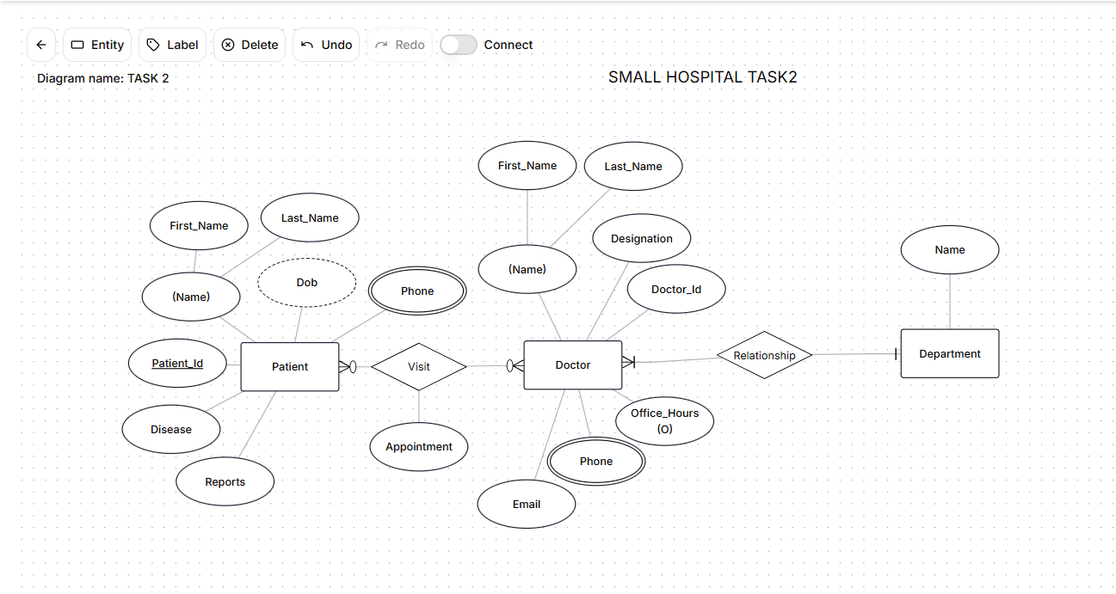

Task 03
Business Case: University Course Registration System.
A university maintains records of students and courses. Students register for courses every semester. Each course is taught by one instructor. An instructor can teach multiple courses. A student can register in many courses, and each course can have many students.
Draw ERD to show entity, attributes and relations between these entities.
Tool: Use online ERD Plus tool.
Solution:
